Task No 01: Create a Temperature converter using JavaScript.

Input:

<html lang="en">

<head>

    <meta charset="UTF-8">

    <meta http-equiv="X-UA-Compatible" content="IE=edge">

    <meta name="viewport" content="width=device-width, initial-scale=1.0">

    <title>Document</title>

    <script>

        function myfunction(){

            const far=parseFloat(prompt("Enter fahrenheit Temperature"));

        let result;

        result=(far-32)\*0.55;

        document.write("Celcius temperature is=" + result)

  }

    </script>

</head>

<body>

    <input type="button" onclick="myfunction()" value="Click here">

</body>

</html>

Output:

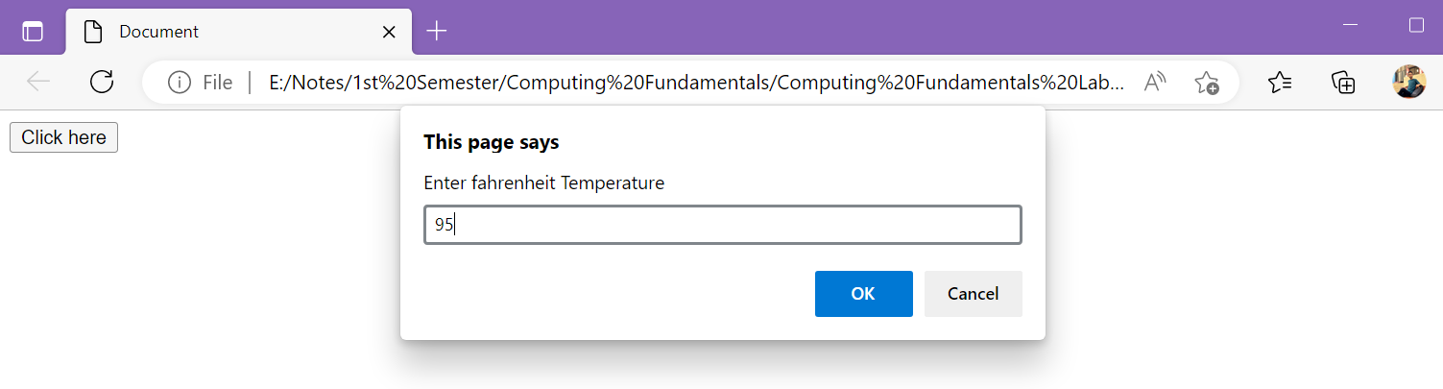

Task No 02: Create a simple Calculator using Prompt Box. Take two inputs from User and ask the operation they want to perform.

Input:

<html>

    <head>

        <script>

            const num1 = parseFloat(prompt('Enter First Number = '));

            const num2 = parseFloat(prompt('Enter Second Number = '));

            var op = prompt('Enter the operator ( +,-,\*,/) :');

            let result;

            if (op=='+')

            {

                result = num1 + num2;

            }

            else if (op == '-')

            {

                result = num1 - num2;

            }

            else if (op == '\*')

            {

                result = num1 \* num2;

            }

            else if (op == '/')

            {

                result = num1/num2;

            }

            document.write("Result of " +num1+ " "+op+ " "+num2+ " = "+result);

        </script>

    </head>

</html>

Output:

